[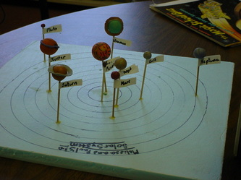](https://mrsstudivan.weebly.com/uploads/5/9/3/7/5937394/7996860_orig.jpg)

[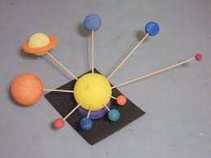](https://mrsstudivan.weebly.com/uploads/5/9/3/7/5937394/6882404_orig.jpg)

[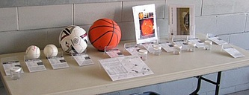](https://mrsstudivan.weebly.com/uploads/5/9/3/7/5937394/6790761_orig.jpg)

[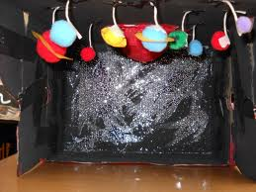](https://mrsstudivan.weebly.com/uploads/5/9/3/7/5937394/7681252_orig.jpg)

[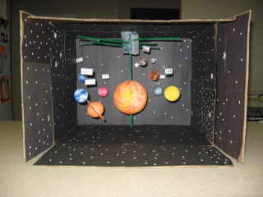](https://mrsstudivan.weebly.com/uploads/5/9/3/7/5937394/4584777_orig.jpg)

[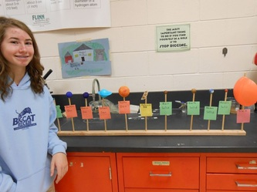](https://mrsstudivan.weebly.com/uploads/5/9/3/7/5937394/8596235_orig.jpg)

[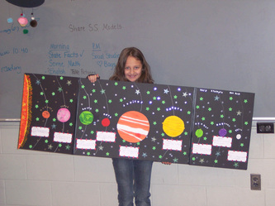](https://mrsstudivan.weebly.com/uploads/5/9/3/7/5937394/2059016_orig.jpg)

[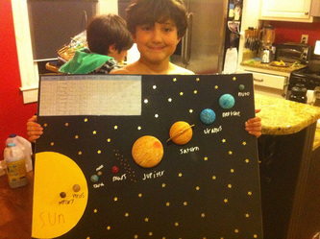](https://mrsstudivan.weebly.com/uploads/5/9/3/7/5937394/958905_orig.jpg)

[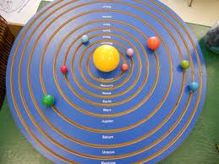](https://mrsstudivan.weebly.com/uploads/5/9/3/7/5937394/5050881_orig.jpg)

[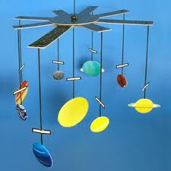](https://mrsstudivan.weebly.com/uploads/5/9/3/7/5937394/6549776_orig.jpg)

Above are some examples of solar system models to help you get an idea of how you want to create your OWN model!! See me if you have any other ideas for your model!